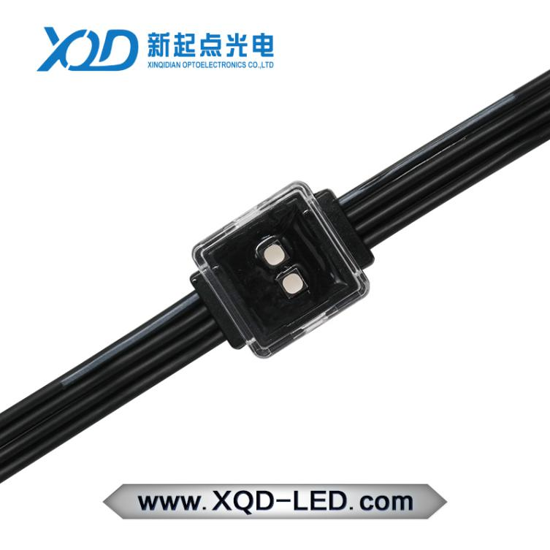
P41.6-2020 point light screen technical parameters

Product basic parameters |  | Product protection parameters
Item | XQD-P41.6-2020-FX | waterproof level | IP66
Size | 25mm*20mm*9.9mm | Shell flame retardancy | V-0
Application | Indoor/outdoor | UV resistance | 4
Weight | 12g | Salt spray test | Salt spray resistance
Shell material | PC | Impact resistance | IK10
Maximum number | 180PCS/chain | Electrical safety level | Class III
Center spacing | Min 4.16CM | safety certificate | CE FCC
Average lifespan | 5000h | Operating temperature | -40℃-55℃
Cable material | PVC | Wire core | 2x0.75mm²+2x0.35mm²
accessories | Aluminum trough, wire buckle
Product optical parameters |  | Product electrical parameters
PCB material |  | FR-4
LED color | RGB | Operating Voltage | DC12V
Beam angle | 120° | rated power | 0.72W
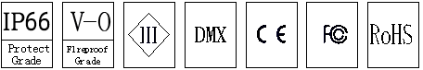  Color resolution | 3*16bit | Supporting system
Lamp bead package | SMD3535*2LED | Control System | DMX512
FLUX | 13lm | Power Systems | DC12V
Brightness | 4.3cd

Product Usage:
1. Use point light source with enlarged wire diameter to support longer distance power supply and signal transmission mode.
2. Flexible installation method: the product is small in size and light in weight, with flexible steel wire rope,
Flexible and diverse installation methods can be realized.
3. With the function of resuming the dead pixels, even if one of the pixels is damaged, it will not affect the subsequent pixels
4. Signal reception, minimize product failure rate.
5. A variety of spacing options, flexible control of project costs.
Light distribution curve Size
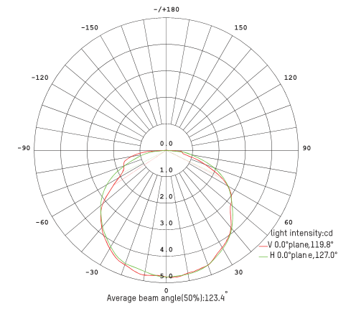
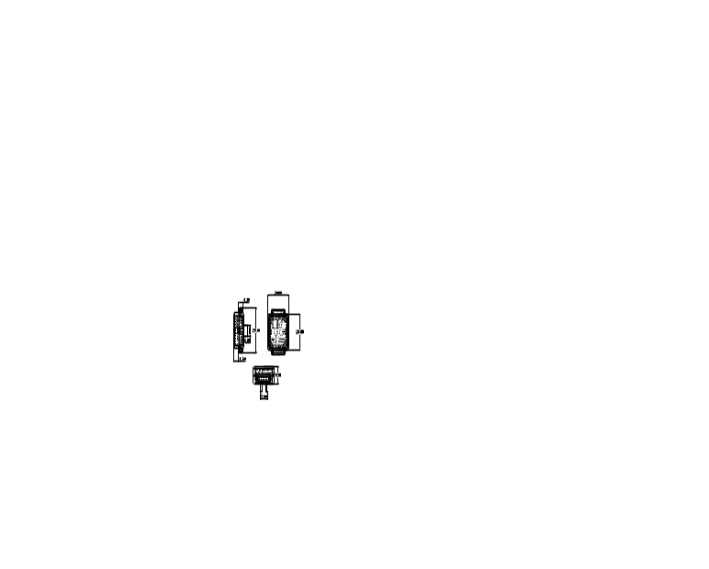

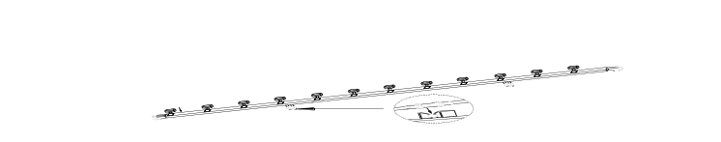

Installation method:
- Install steel wire clip to make screen
2020 point light source screen application instructions
Finished product icon:
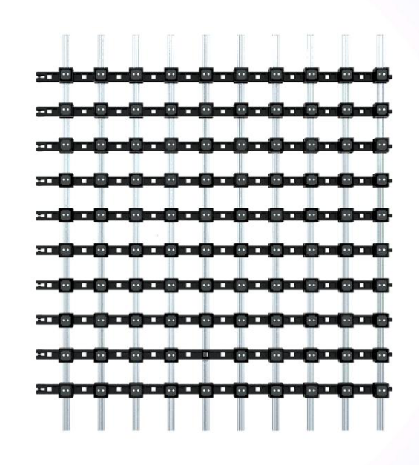  Product basic parameters |  | Optional specifications (can be customized)
Item | 2020 square engineering grid screen
specifications | P41.6 | P83.2 | P124.8
Application | Indoor/outdoor | Indoor/outdoor | Indoor/outdoor
Installation | Steel structure support | Steel structure support | Steel structure support
Load wire | 2.0mmWire fixing (Single module 2pcs) | 2.0mmWire fixing (Single module 2pcs) | 2.0mmWire fixing (Single module 2pcs)
Single module width | 0.5meter/Piece | 0.5meter/Piece | 0.5meter/Piece
Max length of single row | 7m | 14m | 22m
No. of lights per square meter | 576led/m² | 144led/m² | 64led/m²
Power per square meter | 414.7W/m² | 103.6W/m² | 46W/m²
Per square meter weight | 8.03KG/m² | 2.32KG/m² | 1.18KG/m²
Lamp flatness | < 1mm | < 1mm | < 1mm
Viewing distance | >30meter | >60meter | >90meter
Viewing angle | Within 140° | Within 140° | Within 140°
Signal transmission distance | Super five network cable within 90 meters | Super five network cable within 90 meters | Super five network cable within 90 meters
Display mode | Computer/master synchronization | Computer/master synchronization | Computer/master synchronization
Overall transparency | 58% | 81% | 90%
Product introduction：
LED transparent grid screen, transparent, flexible and lightweight
Easy to install and maintain, suitable for a variety of installation methods,
Such as bending, folding, winding, hanging, etc., as a whole
Transparent LED grid screen. Very artistic and creative, free
Synthesize various shapes. Widely used in building facades or skylights, etc.
The production of large screens.
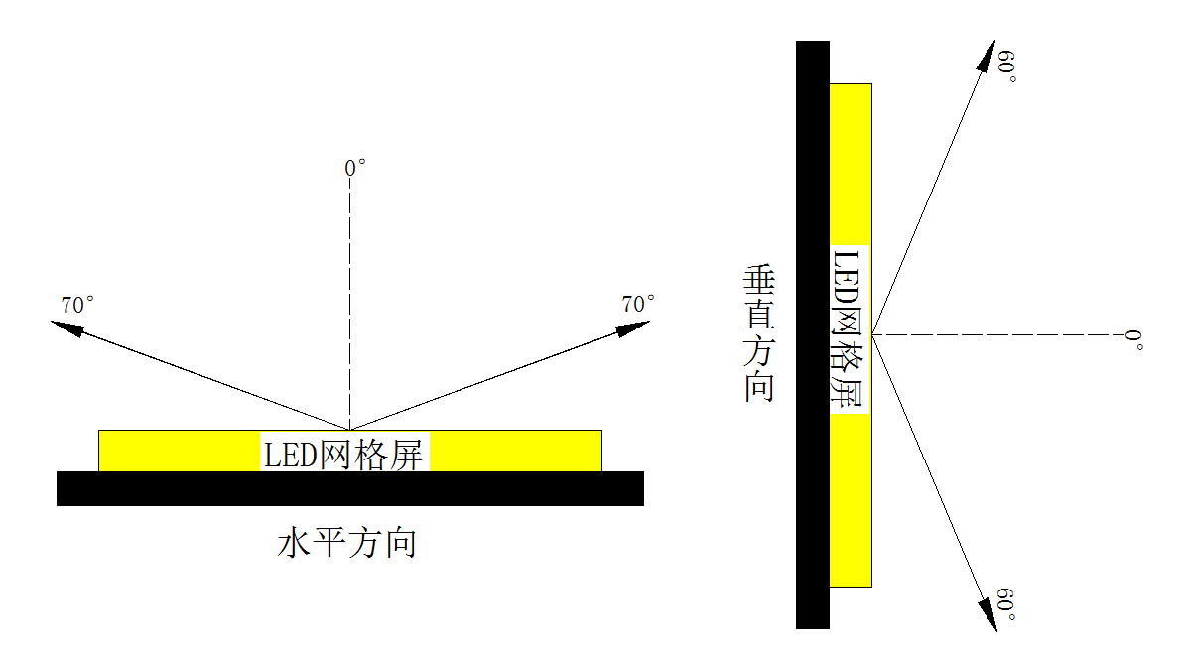
Visual curve :

Structure description:
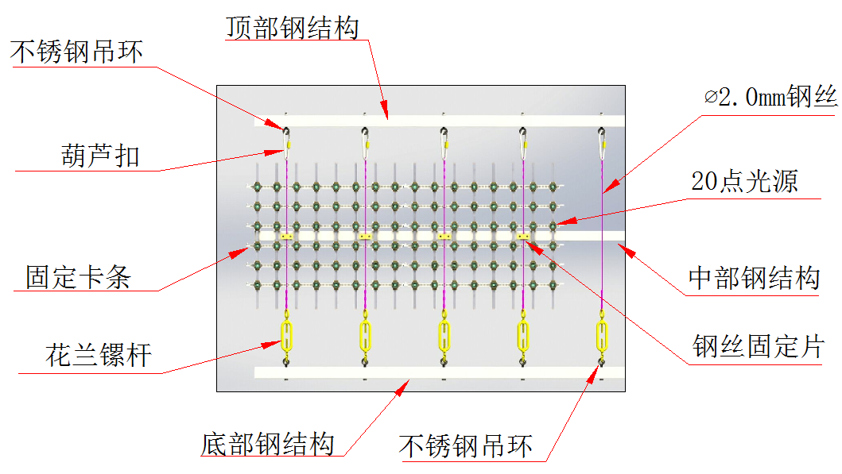

Technical requirements:：
1. All structural parts and the external wall fixed mast, it is recommended to use 316 stainless steel chemical bolt
2. Welding rod specification J422 GB
3. Welds need anti-rust treatment, at least to meet the national standard 3 standard
4. The specific plan is based on the structural deepening map.
Installation wiring instructions:
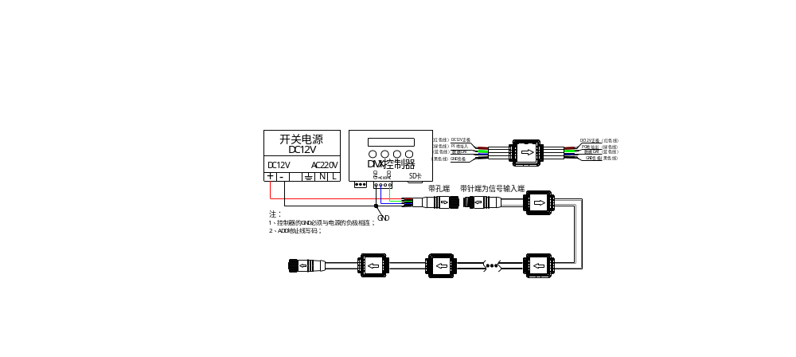1. Connection instructions

- Control system connection instructions
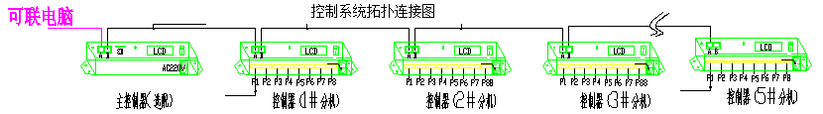

1, the connection between the controller and the controller is 568B connection between the controller, the computer and the controller use two 568B connection, the length of the network cable between the computer and the controller or controller and controller does not exceed 80 meters, the total network cable length of all sub-control connections does not exceed 500 meters, if it is to exceed this distance, the fiber connection is used.
2. The number of points per signal load lamp is controlled within 340 points.
3. Cable pressing method: facing the crystal head with a metal piece side, the crystal head shrapnel side facing the palm, the order of pressing the wire from left to right is:
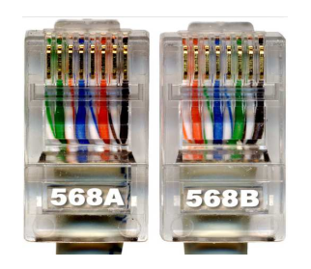
568A: Green White Green Orange White Blue Blue White Orange Brown White Brown
568B: orange white orange green white blue blue white green brown white brown


Remarks
1. Do not carry out the installation operation. Do not pull the cable or force the cable during the installation.
2. This product is DC DC power supply. It is strictly forbidden to use AC AC directly; if the product is damaged, it will not be responsible for product damage.
3. The location of the luminaire should be free of corrosive, explosive, flammable media or dust. The luminaire should be protected from severe vibration and shock.
4. Multiple switching power supplies cannot be used in parallel to avoid damage to the switching power supply. The high voltage input of the switching power supply should be connected to the corresponding leakage protection switch.
5. When installing and debugging, if some of the lamps do not light or do not change color, check:
A. Power supply line voltage
B. Check if the signal path is normally connected.
C. The signal connection terminal has good contact
6. When installing and debugging, if the effect of the change is inconsistent with the actual requirement, check:
A. Is the controller working properly?
B. Is the SD card reading card normal?
C. Is the installation wiring method consistent with the wiring diagram ordering?
7. When installing and debugging, if there is an abnormality such as jitter when individual or part of the lamp changes, check:
A. Whether the controller, lamp, and power supply have a common negative pole and are well connected
B. The signal connection between the controller and the luminaire or between the luminaire and the luminaire exceeds 3 meters.
C. Check if the power supply meets the requirements and if the ripple is within the required range.
D. Flashing or shaking parts Please check the signal connection from the input part, there may be a bad contact.
8. If there is color difference when the lamps are mixed, please check if the power supply from the power supply to the lamp meets the requirements.
9. When configuring the power supply, please configure it according to 80% of the actual power of the power supply. For example, 400W power supply, 400x80%=320W, please use 320W to configure the lamp power.

